# Odin : 1

here is the link to downlaod this VM: -<https://www.vulnhub.com/entry/odin_1,619/>

How to find your IP address :

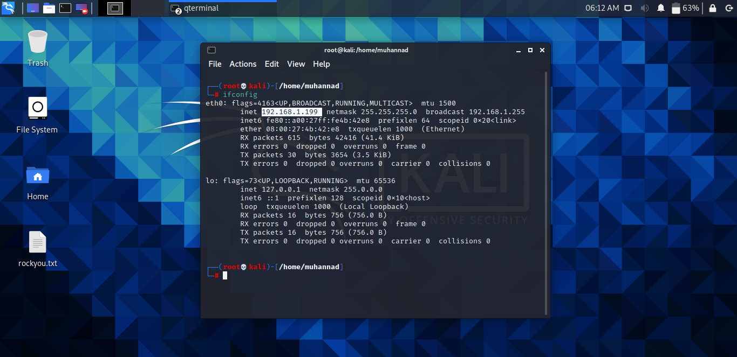

Discovery using netdiscover command:

Let us find the IP address of the machine.

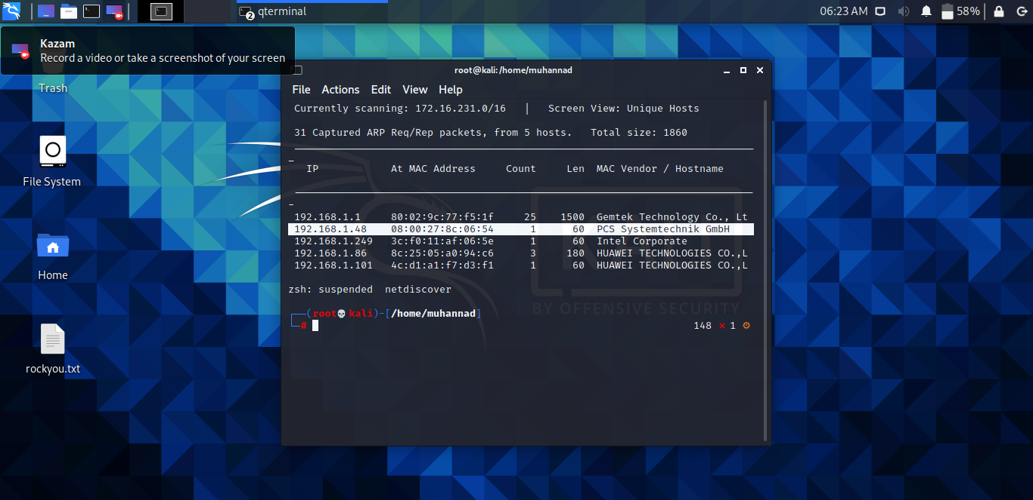

The IP address of our target machine is ‘192.168.1.48’. Now let us find the ports and services running on the machine.

## 2.) Port Scanning and Version Detection

‘# nmap -ST -p- -vv 192.168.1.48’

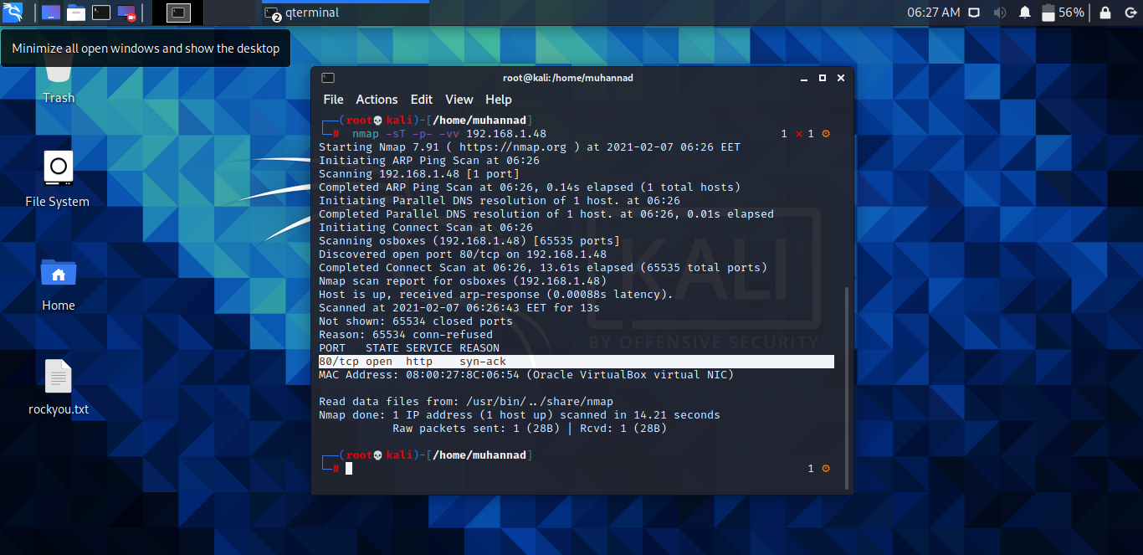

Only port 80 is open on the vm means HTTP.

## 3.) HTTP Enumeration

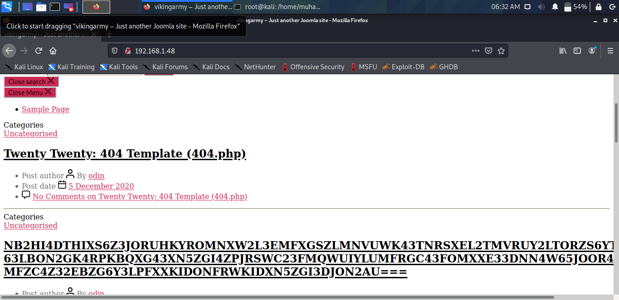

It’s a wordpress installation on the vm and with some manual enumeration I got the right user which is ‘admin’

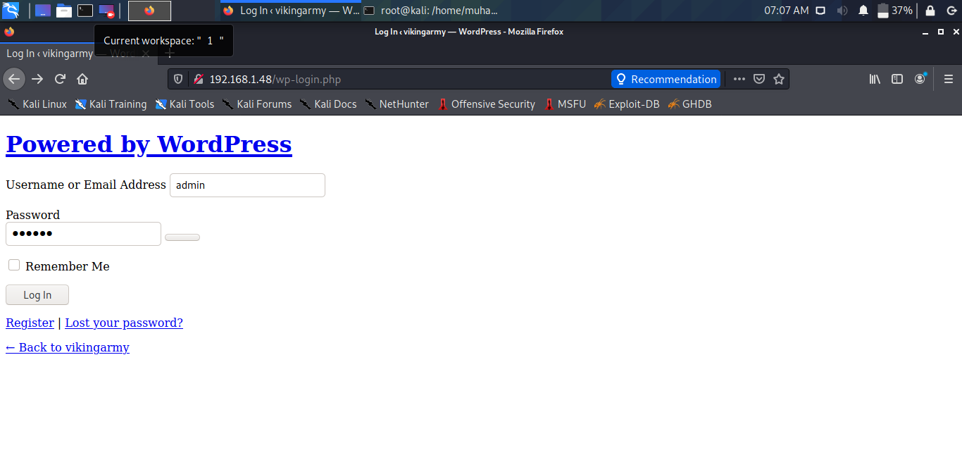

Then used ‘wpscan’ tool to brute-force the password for the user

‘# wpscan -U admin -P /usr/share/wordlists/rockyou.txt --url http://192.168.1.48/

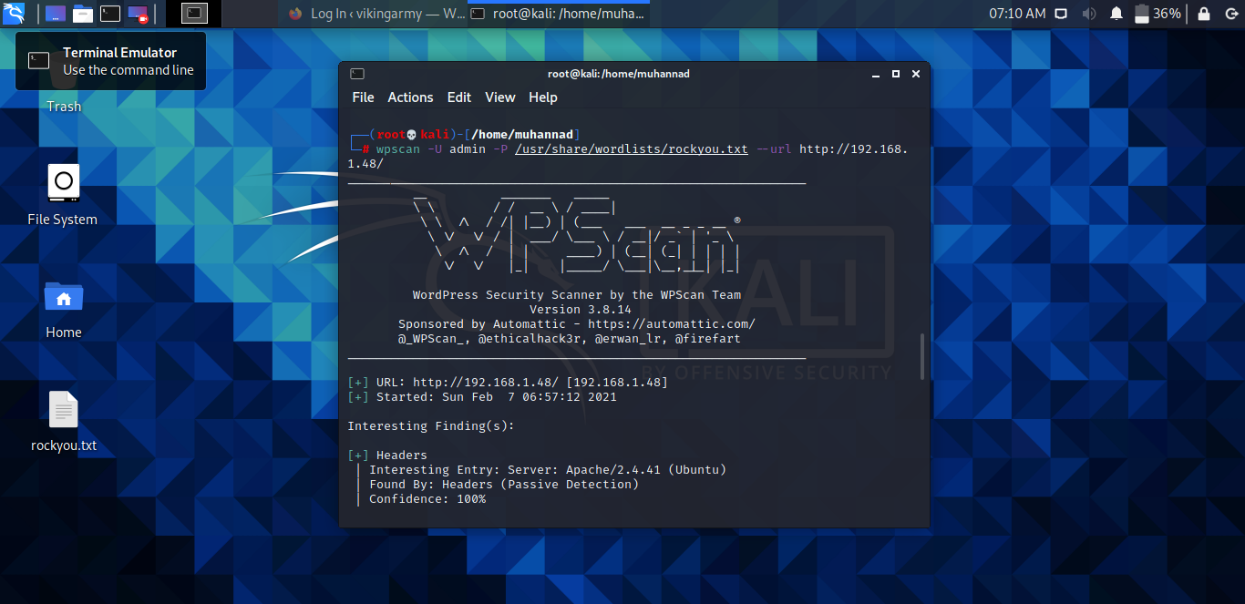

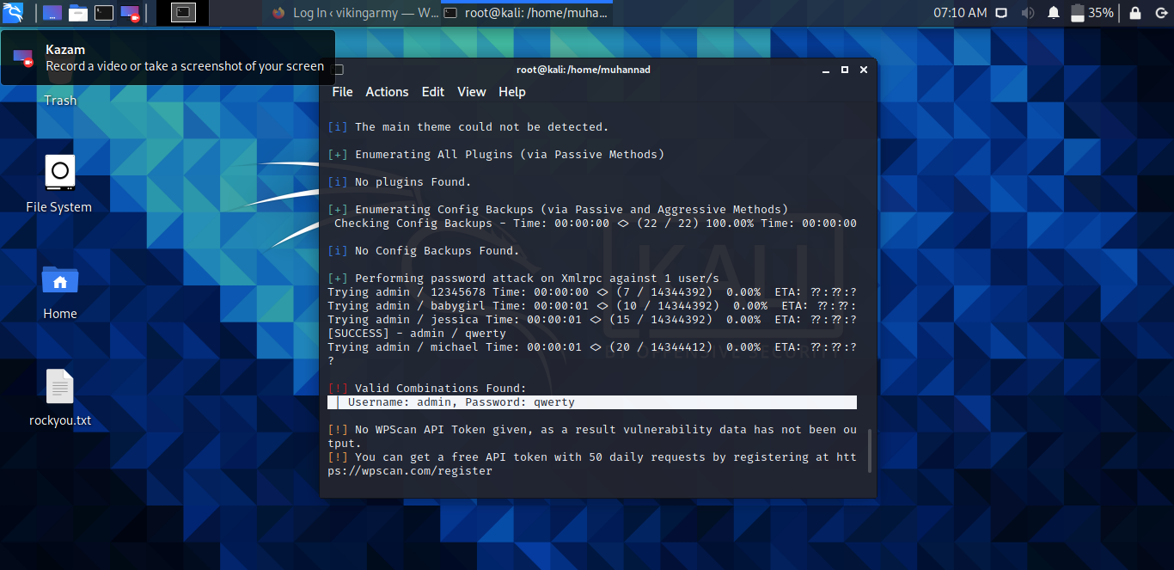

Wordpress exploitation

## 4.) The Shell

I used metasploit and by doing some of required changes I got the shell.

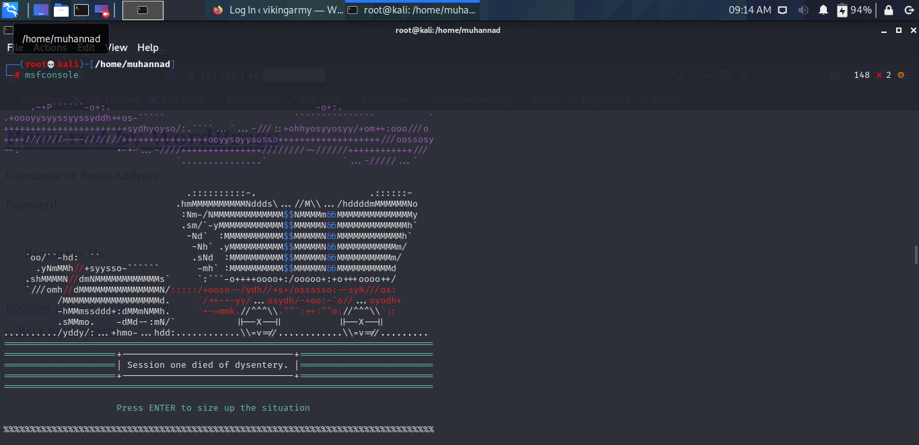  
****#msfconsole****

****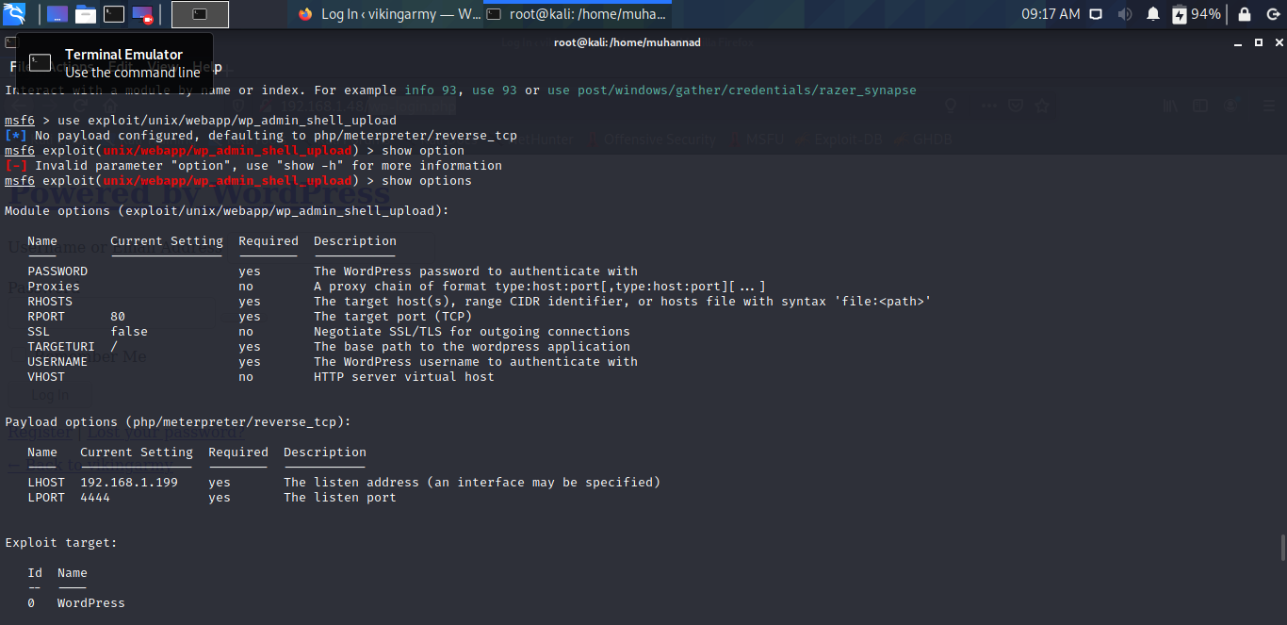****

We have to give the username and password to exploit the admin shell.

